- Some attributes will work differently if use in a dumb terminal.

The purpose of these attributes is to:
1. to be able to make source codes more readable and,
2. to help encourage everyone to write self-documenting source members.

HEX VALUE | TEXT ATTRIBUTE
2A | Red + Blinking
2B | Red + Reverse Image + Blink
2C | Red + Underline
2D | Red + Reverse Image + Underline
2E | Red + Underline + Blink
20 | Delimiter
21 | Reverse Image
22 | Highlight
23 | Reverse Image + Highlight
24 | Underline
25 | Reverse Image + Underline
26 | Highlight + Underline
27 | Hidden
28 | Red
29 | Red + Reverse Image
3A | Blue
3B | Blue + Reverse Image
3C | Pink + Underline
3D | Pink + Underline + Reverse Image
3E | Blue + Underline
30 | Dotted Underline + Highlight
31 | Dotted Underline + Reverse Image + Highlight
32 | Yellow + Dotted Underline
33 | Yellow + Reverse Image + Dotted Underline
34 | Dotted Full Underline
35 | Reverse Image + Dotted Full Underline
36 | Yellow + Dotted Full Underline
37 | Hidden + Dotted Underline
38 | Pink
39 | Pink + Reverse Image

Using Client Access Express for Windows
Assigning Keys for TEXT ATTRIBUTES:

Go to Edit
Preferences
Keyboards…

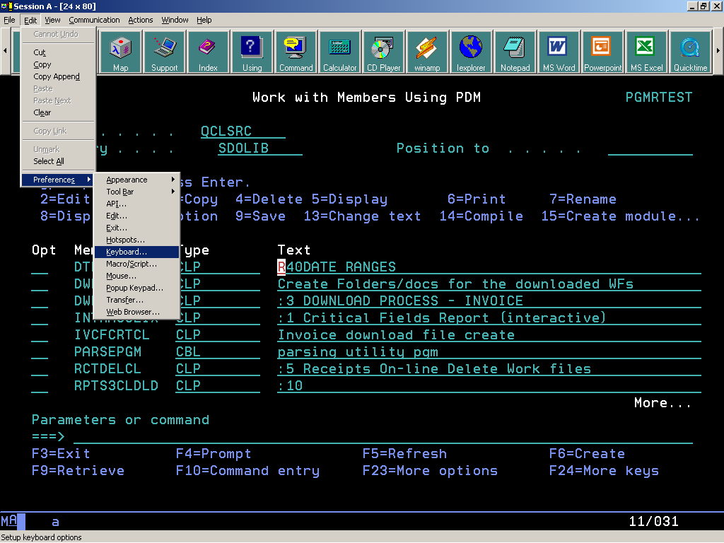

Click on Customize…

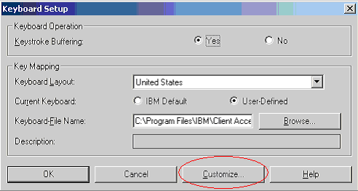
Click on the letter you wish to assign the attributes.
As shown on the table below, “H” was selected and the attribute for HIGHLIGHT
which is 22 was type in the Alt box as “apl 22”
Save your attributes assignment by clicking on File and chose Save

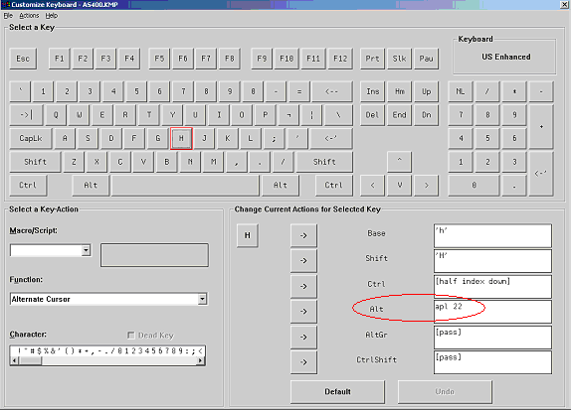

You can use these attributes when using Soure Entry Utility (SEU) or on text descriptions.
As for the sample above, you can highlight any text by pressing [ALT] + [H] before any text
you want to highlight and press [enter] to effect the attribute.

